# Materials and method

## Case-study description and modelling

The case-study is an office building located in the Mediterranean area. As shown in Figure 1, the building (Figure 2) is part of a building complex of the marine area of Licata, a city in Southern Italy. It includes 8 offices, other zones used as bathrooms area and a corridor.

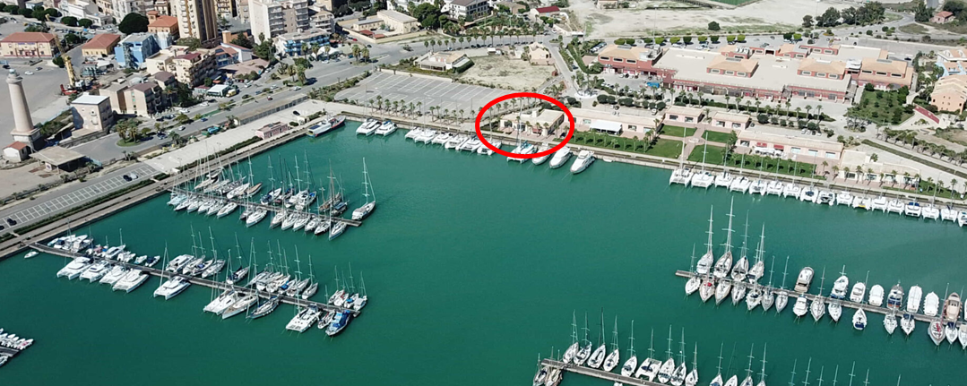

Figure 1: Location of the office building case-study.

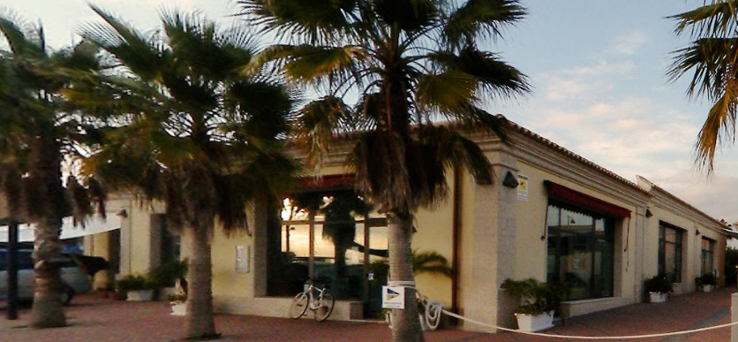

Figure 2: Description of the office building case-study.

Table 1 shows the main characteristics of the case-study. Real data of the building regarding the geometry, thermophysical properties, energy systems, energy consumption and use were acquired during the technical inspection phase which included a technical visit and interviews with stakeholders.

Table 1: Overview of the main technical data of the building.

|  |  |  |  |  |  |  |  |  |
| --- | --- | --- | --- | --- | --- | --- | --- | --- |
| **Trasmittance of building structures** | **Interior walls**  **U=2.02 [W/(m2 K)]** | **Exterior walls**  **U=0.77 [W/(m2 K)]** | | **Ground floor**  **U=1.53 [W/(m2 K)]** | | **Exterior Roof**  **U=2.24 [****W/(m2 K)]** | | **Windows**  **U=1.27 [W/(m2 K)]** |
| **Geometrical data** | **Roof area**  **Ar=360.12 [m2]** | **Floor area**  **Af=360.12 [m2]** | | **Roof typology**  **Flat roof** | | **Exterior Percent Glazing**  **Gl=24 [%]** | | |
| **Use data and other information** | **Lighting**  **8.31 [W/m2]** | | **Electric equipment**  **20.97 [W/m2]** | | **Number of zones**  **13 [-]** | | **Construction year**  **2011 [-]** | |

The building is equipped with an air-cooled reversible heat pump that generates chilled water for space cooling and hot water for space heating, distributed via a fan coil system. COP and EER of this base case are, respectively, equal to 2.8 and 2.44.

The building was modelled and simulated in the TRNSYS 18 environment. Figure 3-4-5 illustrates some thermal zones of the SketchUp-TRNSYS 3D model.

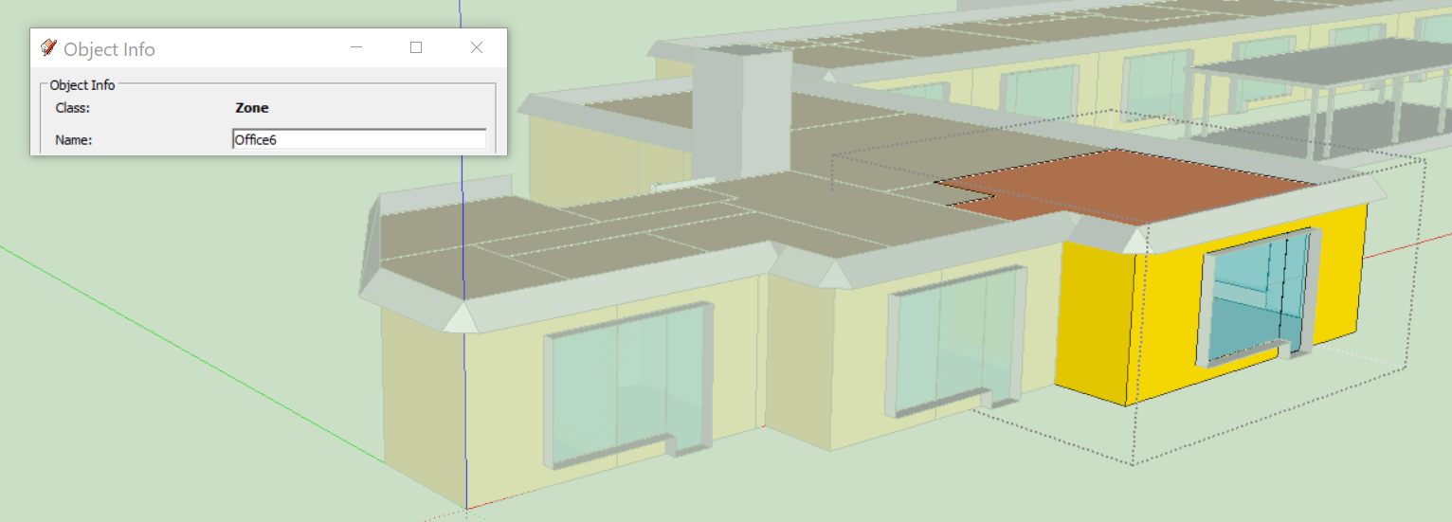

Figure 3: Zone Office 6, South view of the office building 3D model.

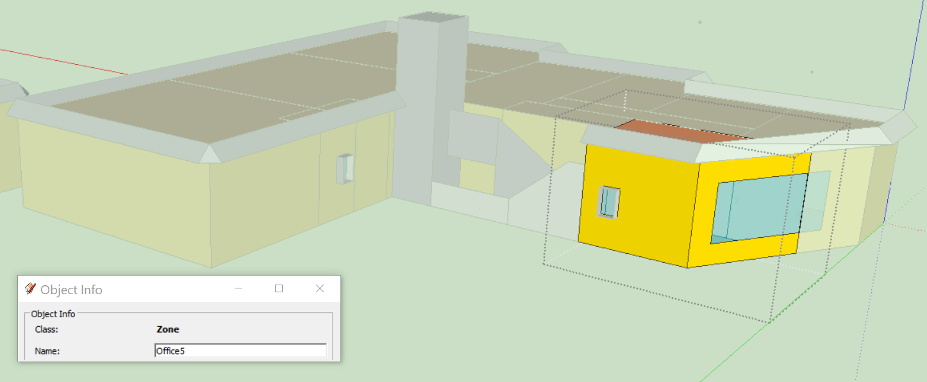

Figure 4: Zone Office 5, Noth view of the office building 3D model.

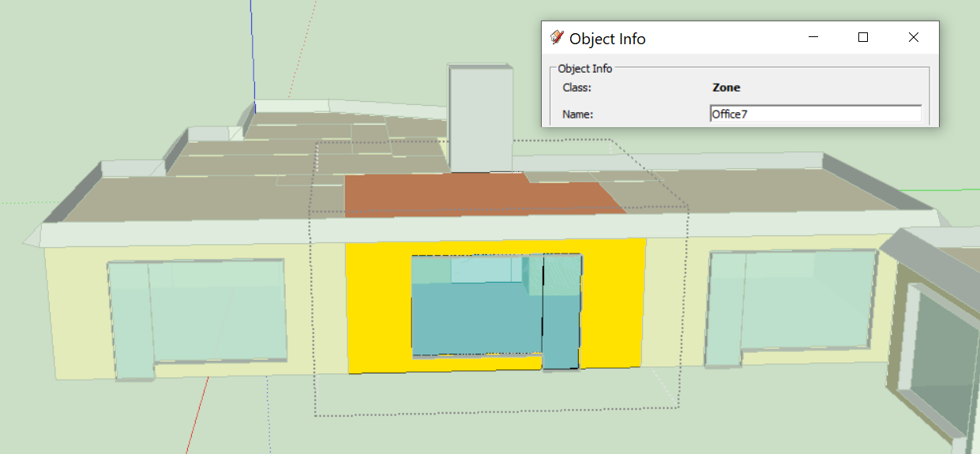

Figure 5: Zone Office 7, East view of the office building 3D model.

The model was calibrated on the base of real data available of the electricity consumption, by achieving limited deviations between simulated data and measure data.

## Draft of the results:

Table 2: Summary of the monthly and yearly values of the building's energy demand.

|  |  |  |  |  |
| --- | --- | --- | --- | --- |
|  | **Total electricity demand [kWh]** | **Calibration deviation [%]** | **Electricity demand for space heating [kWh]** | **Electricity demand for space cooling [kWh]** |
| **Jan** | 3184.91 | 9.49% | 1969.11 | 0.00 |
| **Feb** | 3233.78 | -1.38% | 2056.25 | 0.00 |
| **Mar** | 1874.75 | 7.88% | 609.14 | 0.37 |
| **Apr** | 1630.53 | 4.41% | 408.02 | 4.16 |
| **May** | 1835.10 | -4.19% | 1.31 | 573.81 |
| **Jun** | 2527.61 | 4.45% | 0.00 | 1308.10 |
| **Jul** | 3508.74 | -6.69% | 0.00 | 2206.62 |
| **Aug** | 3392.27 | -2.57% | 0.00 | 2132.10 |
| **Sep** | 2975.31 | -8.70% | 0.00 | 1711.31 |
| **Oct** | 2163.71 | -0.79% | 47.35 | 815.01 |
| **Nov** | 2576.25 | 3.80% | 1329.85 | 27.43 |
| **Dec** | 3178.30 | -1.61% | 2000.56 | 0.04 |
| Annual | 32081.25 | 0.19% | 8421.59 | 8778.95 |

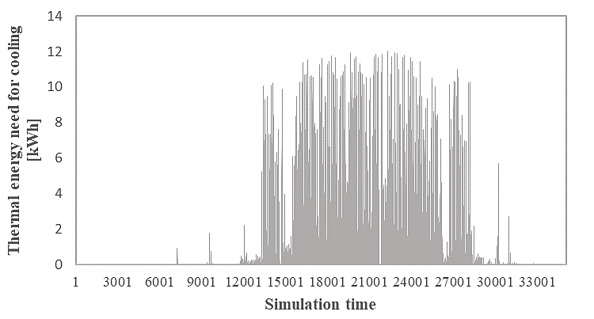

Figure 6: Annual distribution of the thermal energy demand for space cooling (15 minutes time-step profiles).

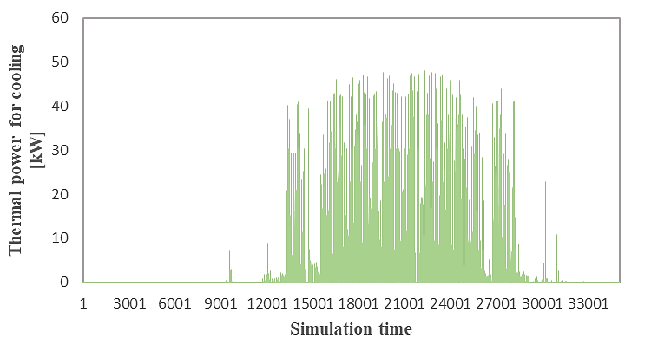

Figure 7: Annual distribution of the thermal power requirement for space cooling (15 minutes time-step profiles).

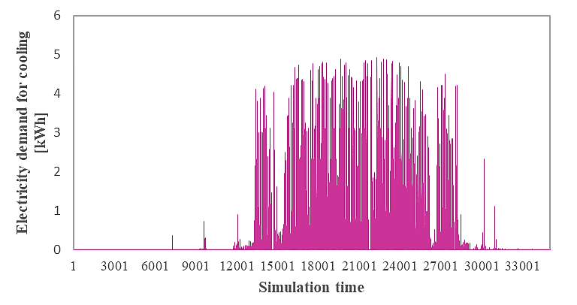

Figure 8: Annual distribution of the actual electricity demand for space cooling (15 minutes time-step profiles). base scenario based on the existing heat pump system.